**LABORATORY**

Microcontrollers

LAB 2

|  |  |
| --- | --- |
| **NAME** | KELVIN MAKAKA |
| **MATRICULATION NUMBER** | 26219 |
| **STUDY COURSE** | MECHATRONIC SYSTEMS ENGINEERING |
| **PRESENTATION DATE** | 29.11.2020 |
| **SUBMISSION DATE** | 01.12.2020 |

Task 1.

1. PB0 is connected to LED.
2. Use a toggle function that toggles the LED every second using Timer1 and a Pre-scale value of 64
3. TCNT value used is 62500

Task 2.

1. PB0 output
2. Prescaler of 1
3. A 300 Hz signal with 50% duty cycle was produced.
4. Frequency is checked with buzzer
5. The TCNT value used is 13333

Task 5.

1. PD2 and PD3 as input with their pullups enabled
2. PB0, PB1 and PB2 set as output (red, yellow and green LEDs respectively)
3. YellowLED is switched on followed by a delay (250ms) then turned off followed by another delay.
4. If statement where Button1 (PD2) switches on the redLED (PB0) and Button2 (PD3) switches off the redLED.
5. Holding and pressing the button is quick succession had no effect on the redLED.

Task 6.

1. If statement from previous task is removed and external digital interrupt is used.
2. Interrupt is enabled by setting INT0 and INT1 in enable interrupt mask.
3. ISC01 and ISC11 is set to trigger when button changes on the falling edge.
4. Falling edge interrupt setting is preferred in this instance to catch the event where the button is pressed because when the push-button is pressed the input signal will go from high to low which is a falling edge.
5. EIMSK |= (1 << INT0) and EIMSK |= (1 << INT1); enables INT0 and INT1
6. ISR was written for INT0 and INT1 vectors outside the main function.
7. If statement is NOT necessary in the ISR because we are already in the BUS when this interrupt is triggered. 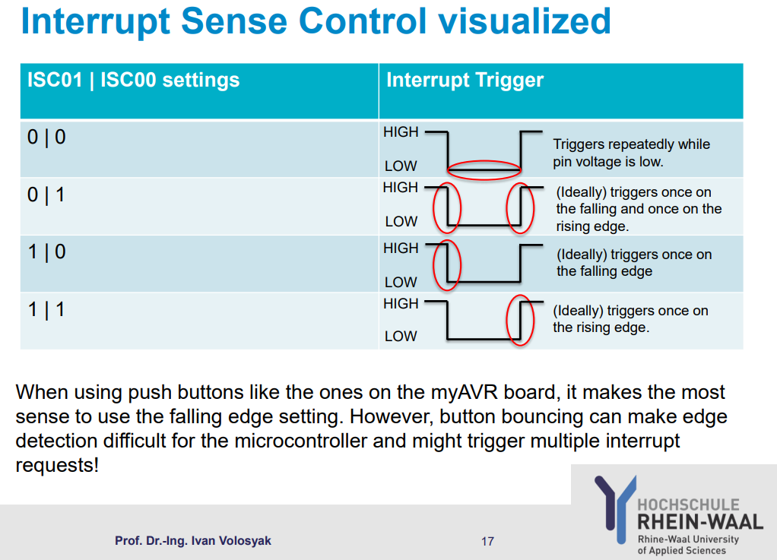

Task 7

1. Timer enabled
2. Prescale = 256
3. Timer overflow for timer 1 was enabled in TIMSK1 register.
4. ISR for Timer1 overflow vector was written to toggle greenLED.

Task 8.

1. Compare mode is enabled TIMSK1 |= (1 << OCIE1A);
2. OCR1A = 1000; is set as the value to compare when the Timer counter reaches 1000.
3. Green Led switches ON when the Timer/Counter 1 overflows.
4. ISR Timer1 compare vector was written to switch off led when 1000 is reached.